Example Posts:

Facebook:

https://vimeo.com/219565546

Caption: “For the first time in my journey – my faith, pain and hope can join a river of movement for a purpose that is greater than my life…I am deeply grateful.”- Pilgrimage Attendee

Register at: www.durhamcares.org/pilgrimage

Instagram:
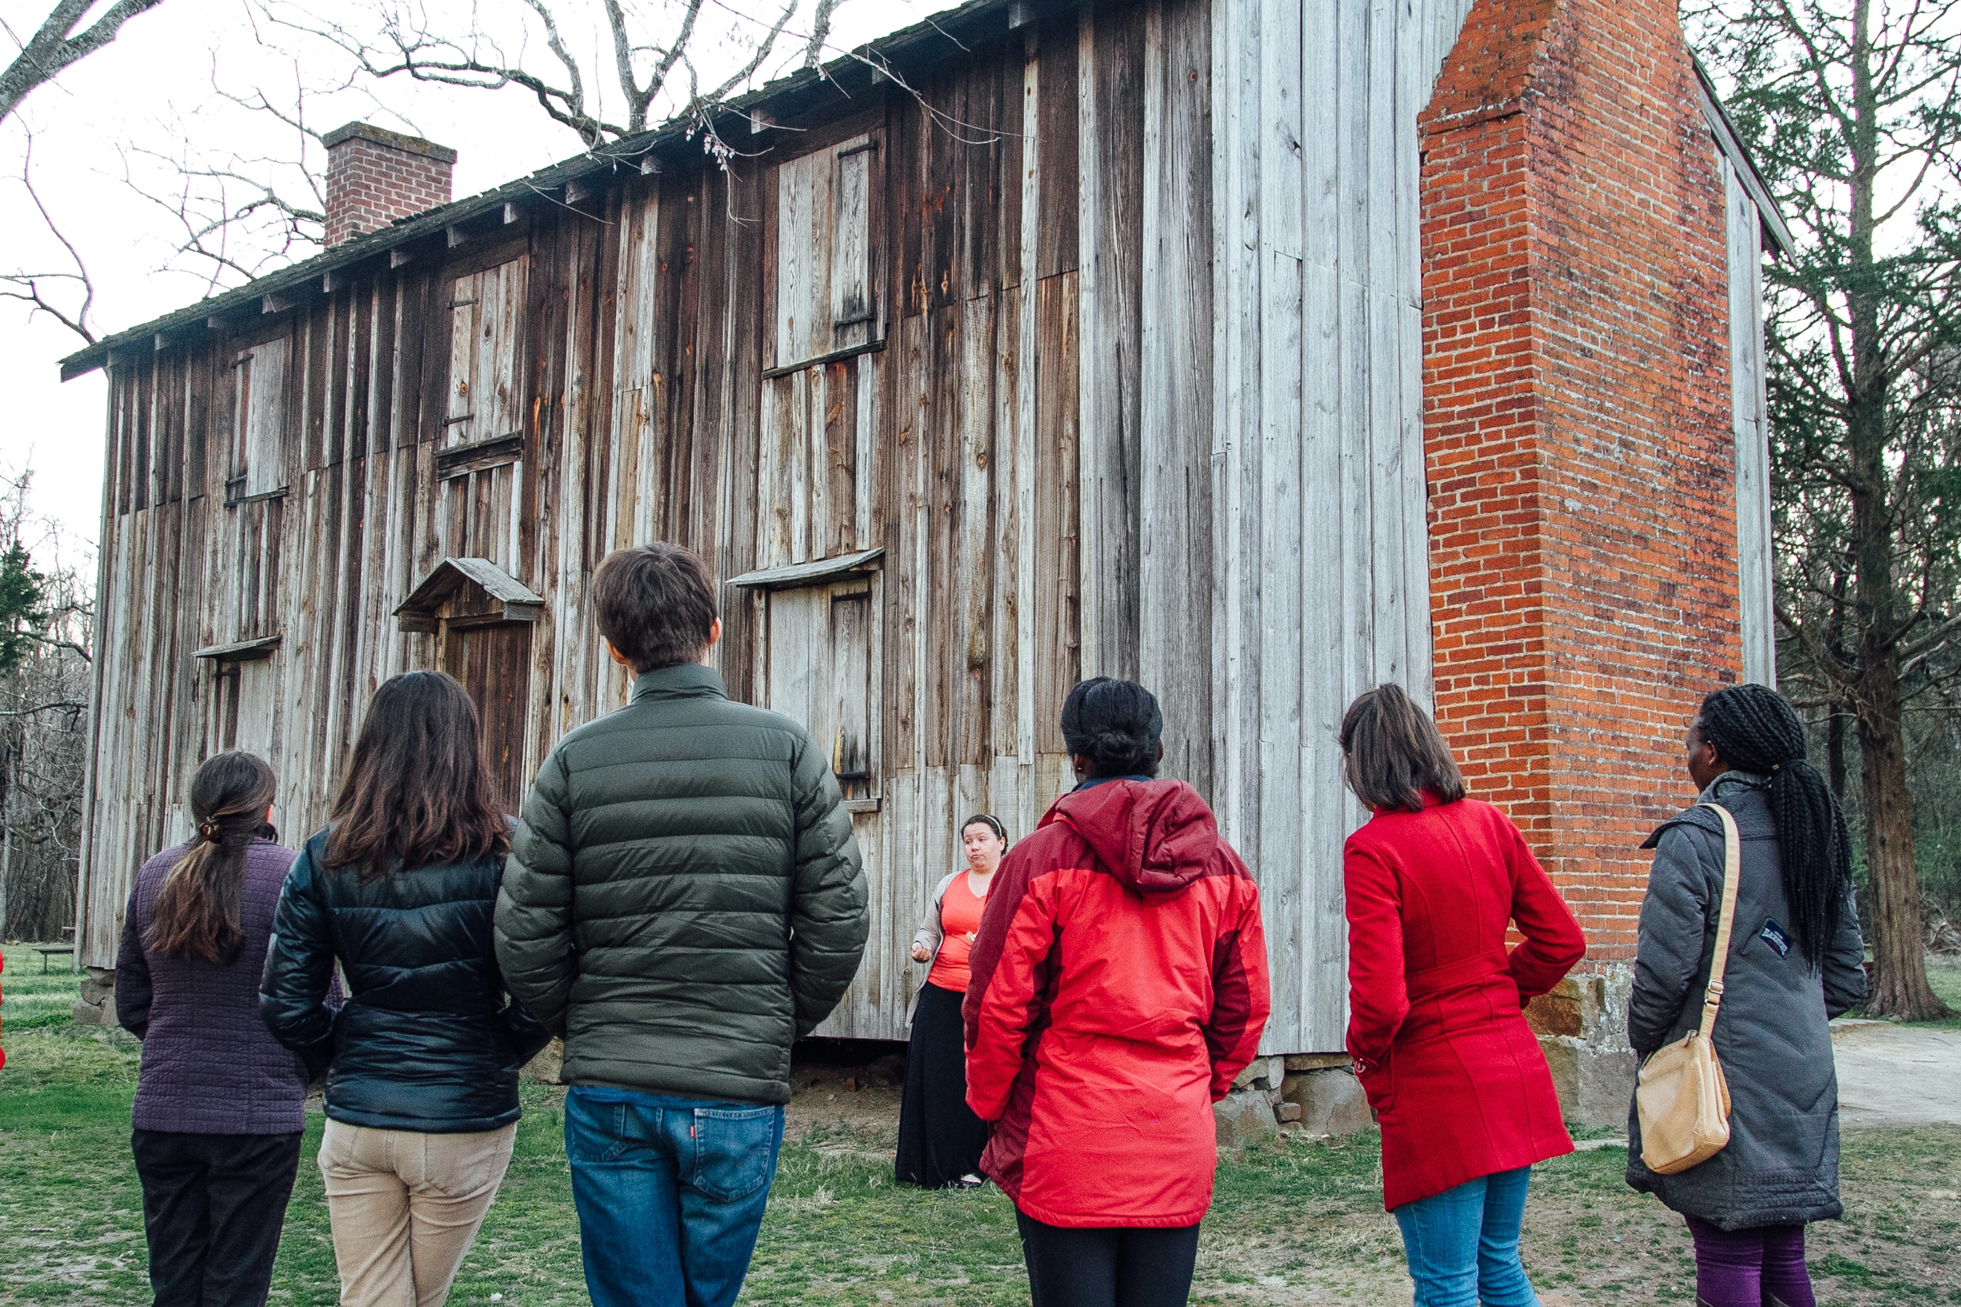

Join us the weekend of March 20th to discover how your spiritual journey is connected to the place you live. You will have the chance to immerse yourself in the story of the city and interact with others from your community.

“The pilgrimage helped remind me that my place is bigger than just my house. Durham is my home.”- Pilgrimage Alumni

Register at: www.durhamcares.org/pilgrimage

Instagram week of:

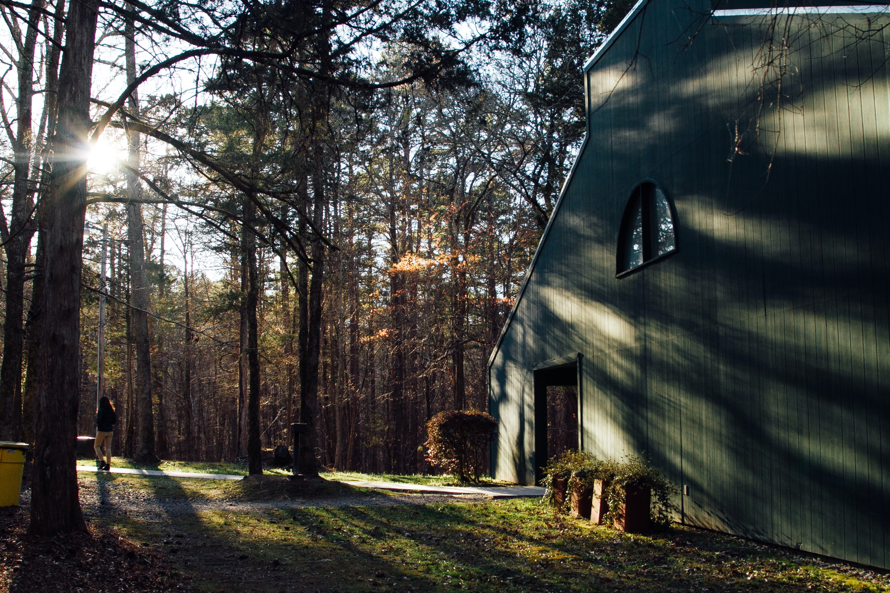
This weekend, pilgrimage participants will partake in a transformative experience where they will learn to connect their story to Durham’s story and God’s story.

Here are some quotes from past participants:
“The most valuable part was making connections with the wonderful people in our group.”

“I had never really thought about how God’s story, my story, and Durham’s story were all intertwined. Now I think about that a lot!”

Register at: www.durhamcares.org/pilgrimage

Instagram:
“It confirmed for me that God is in the racial conversation and that He wants me to be a part of it. I think He is working to bring healing and reconciliation to people today.” – Pilgrimage Attendee

Join us the weekend of March 20 for this transformative experience.

Register at: www.durhamcares.org/pilgrimage

